Community garden update, a few pics of progress so far.
November 2024
From Cllr Alasdair Garnett.

The seating area is finished, with two picnic tables refurbished by Cllr Trevor Wearne looking good and being enjoyed. The soil has been raked down to the top of the sleepers to make a more gentle bank (see below) and can soon be planted up with herbs, flowers, fruit.
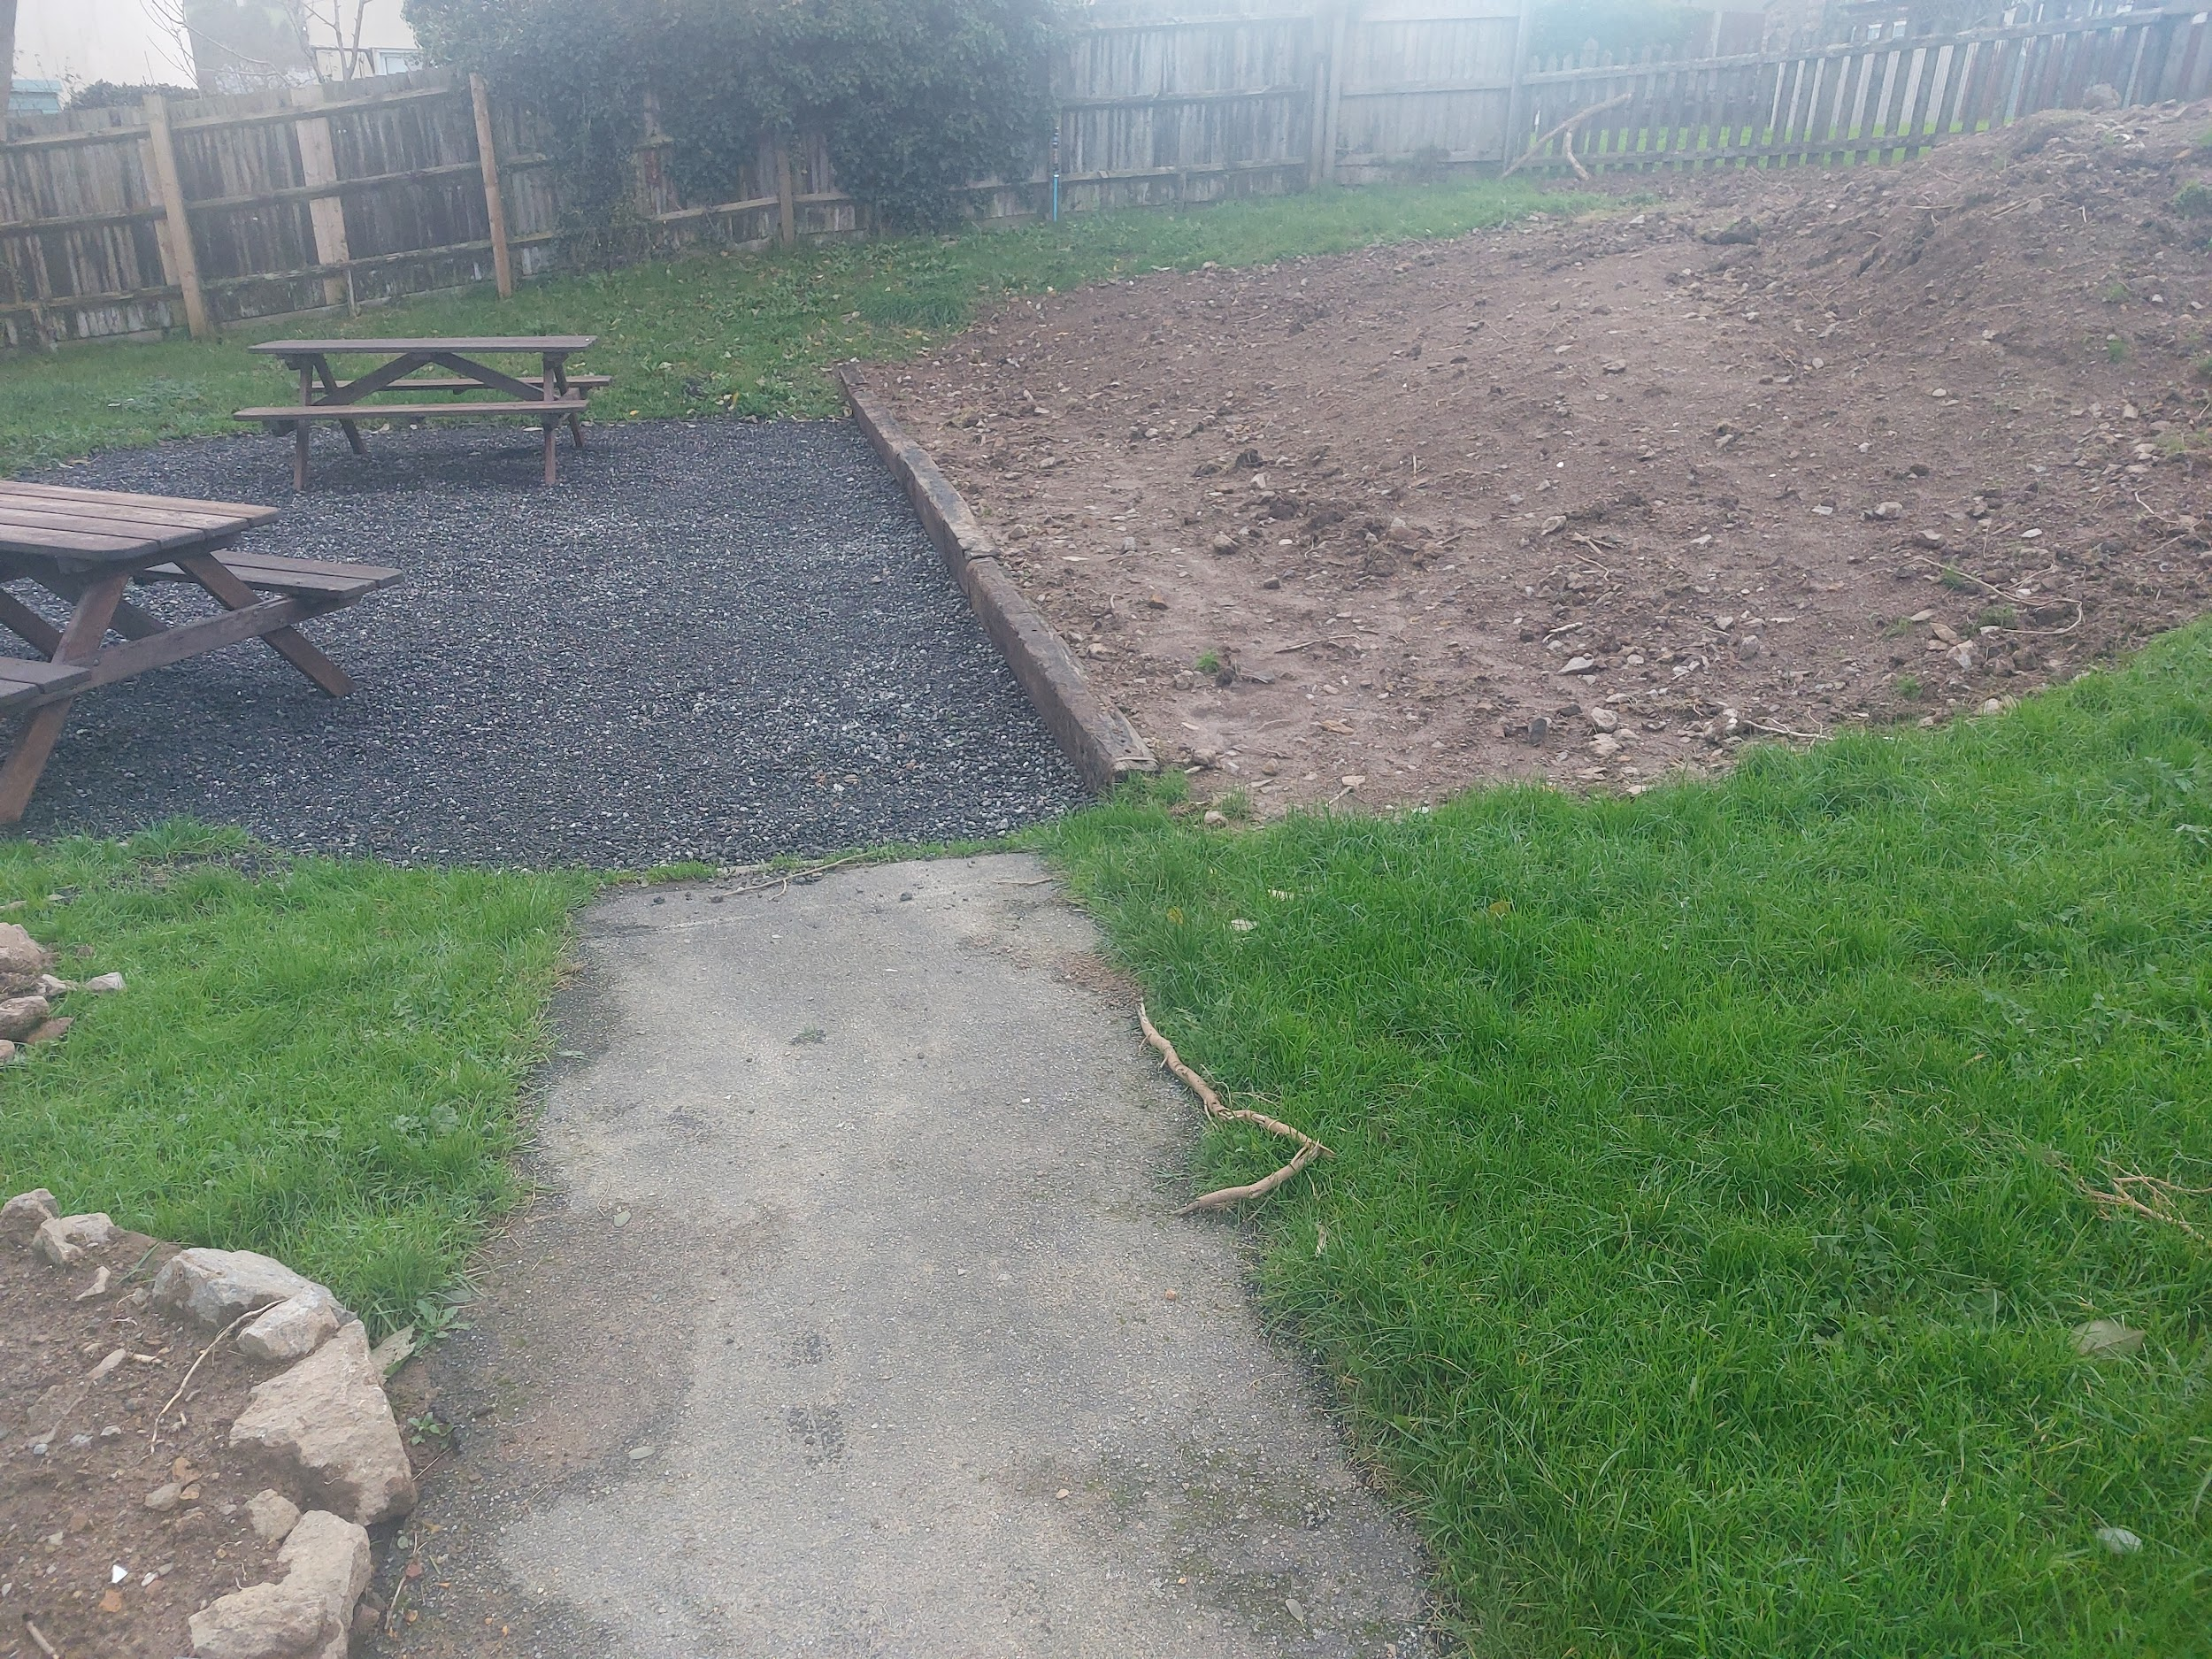
The rest of the soil will be used to make beds and fill planters
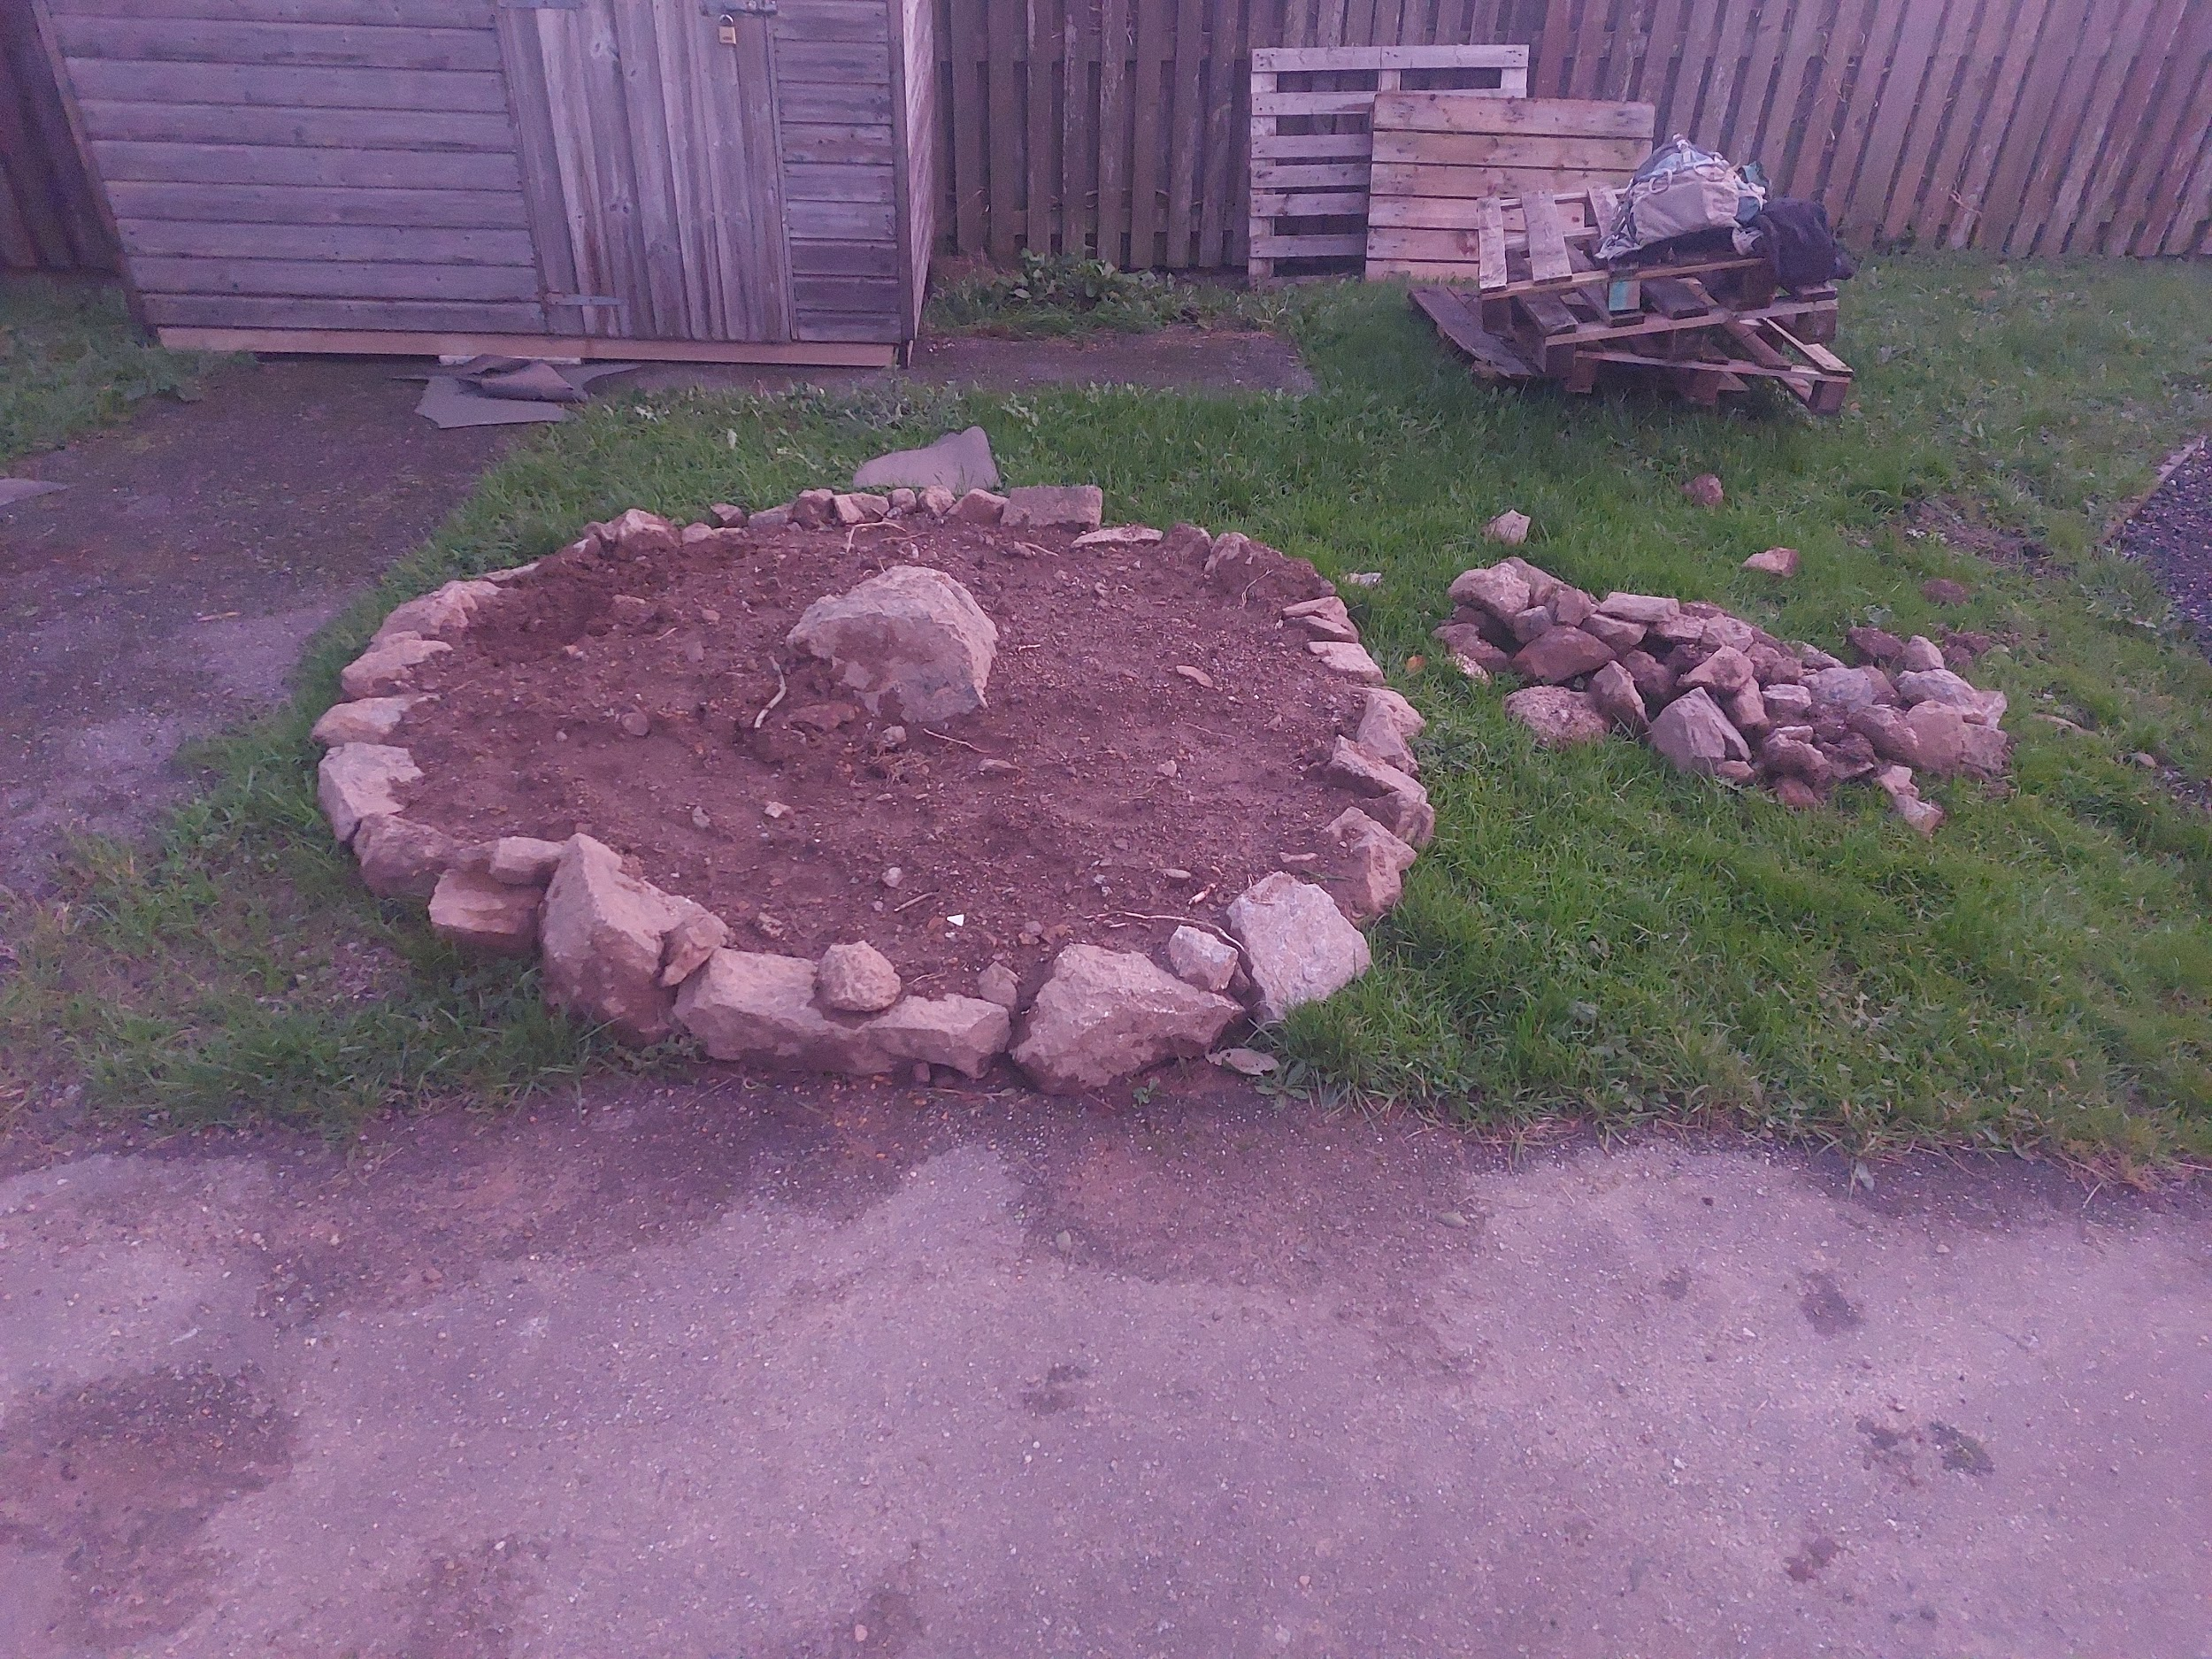

Cllr Sam Tancock’s herb spiral is coming on, with the new shed kindly donated by Cllr Helen Billham and refurbished and installed by Cllr Trevor Wearne (thanks both!) in the background.

Pallets on the right will be remade into compost bays soon.

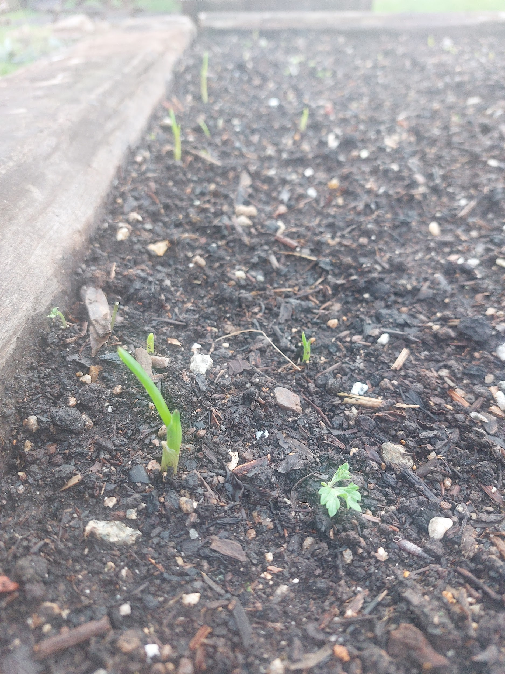

First veg crop starting to appear. Red and brown onions planted with 7 year old Dan, one of our most regular volunteers

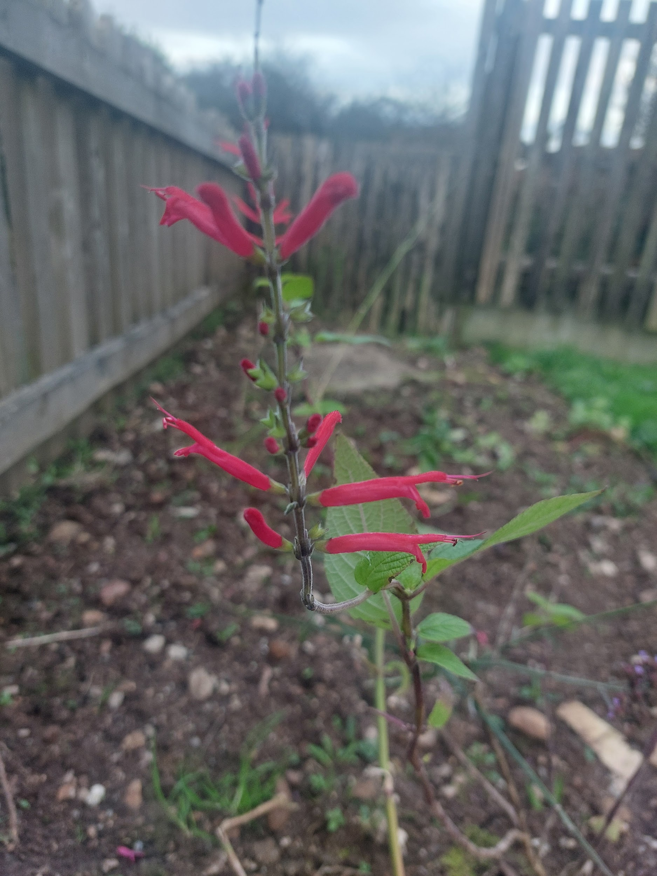
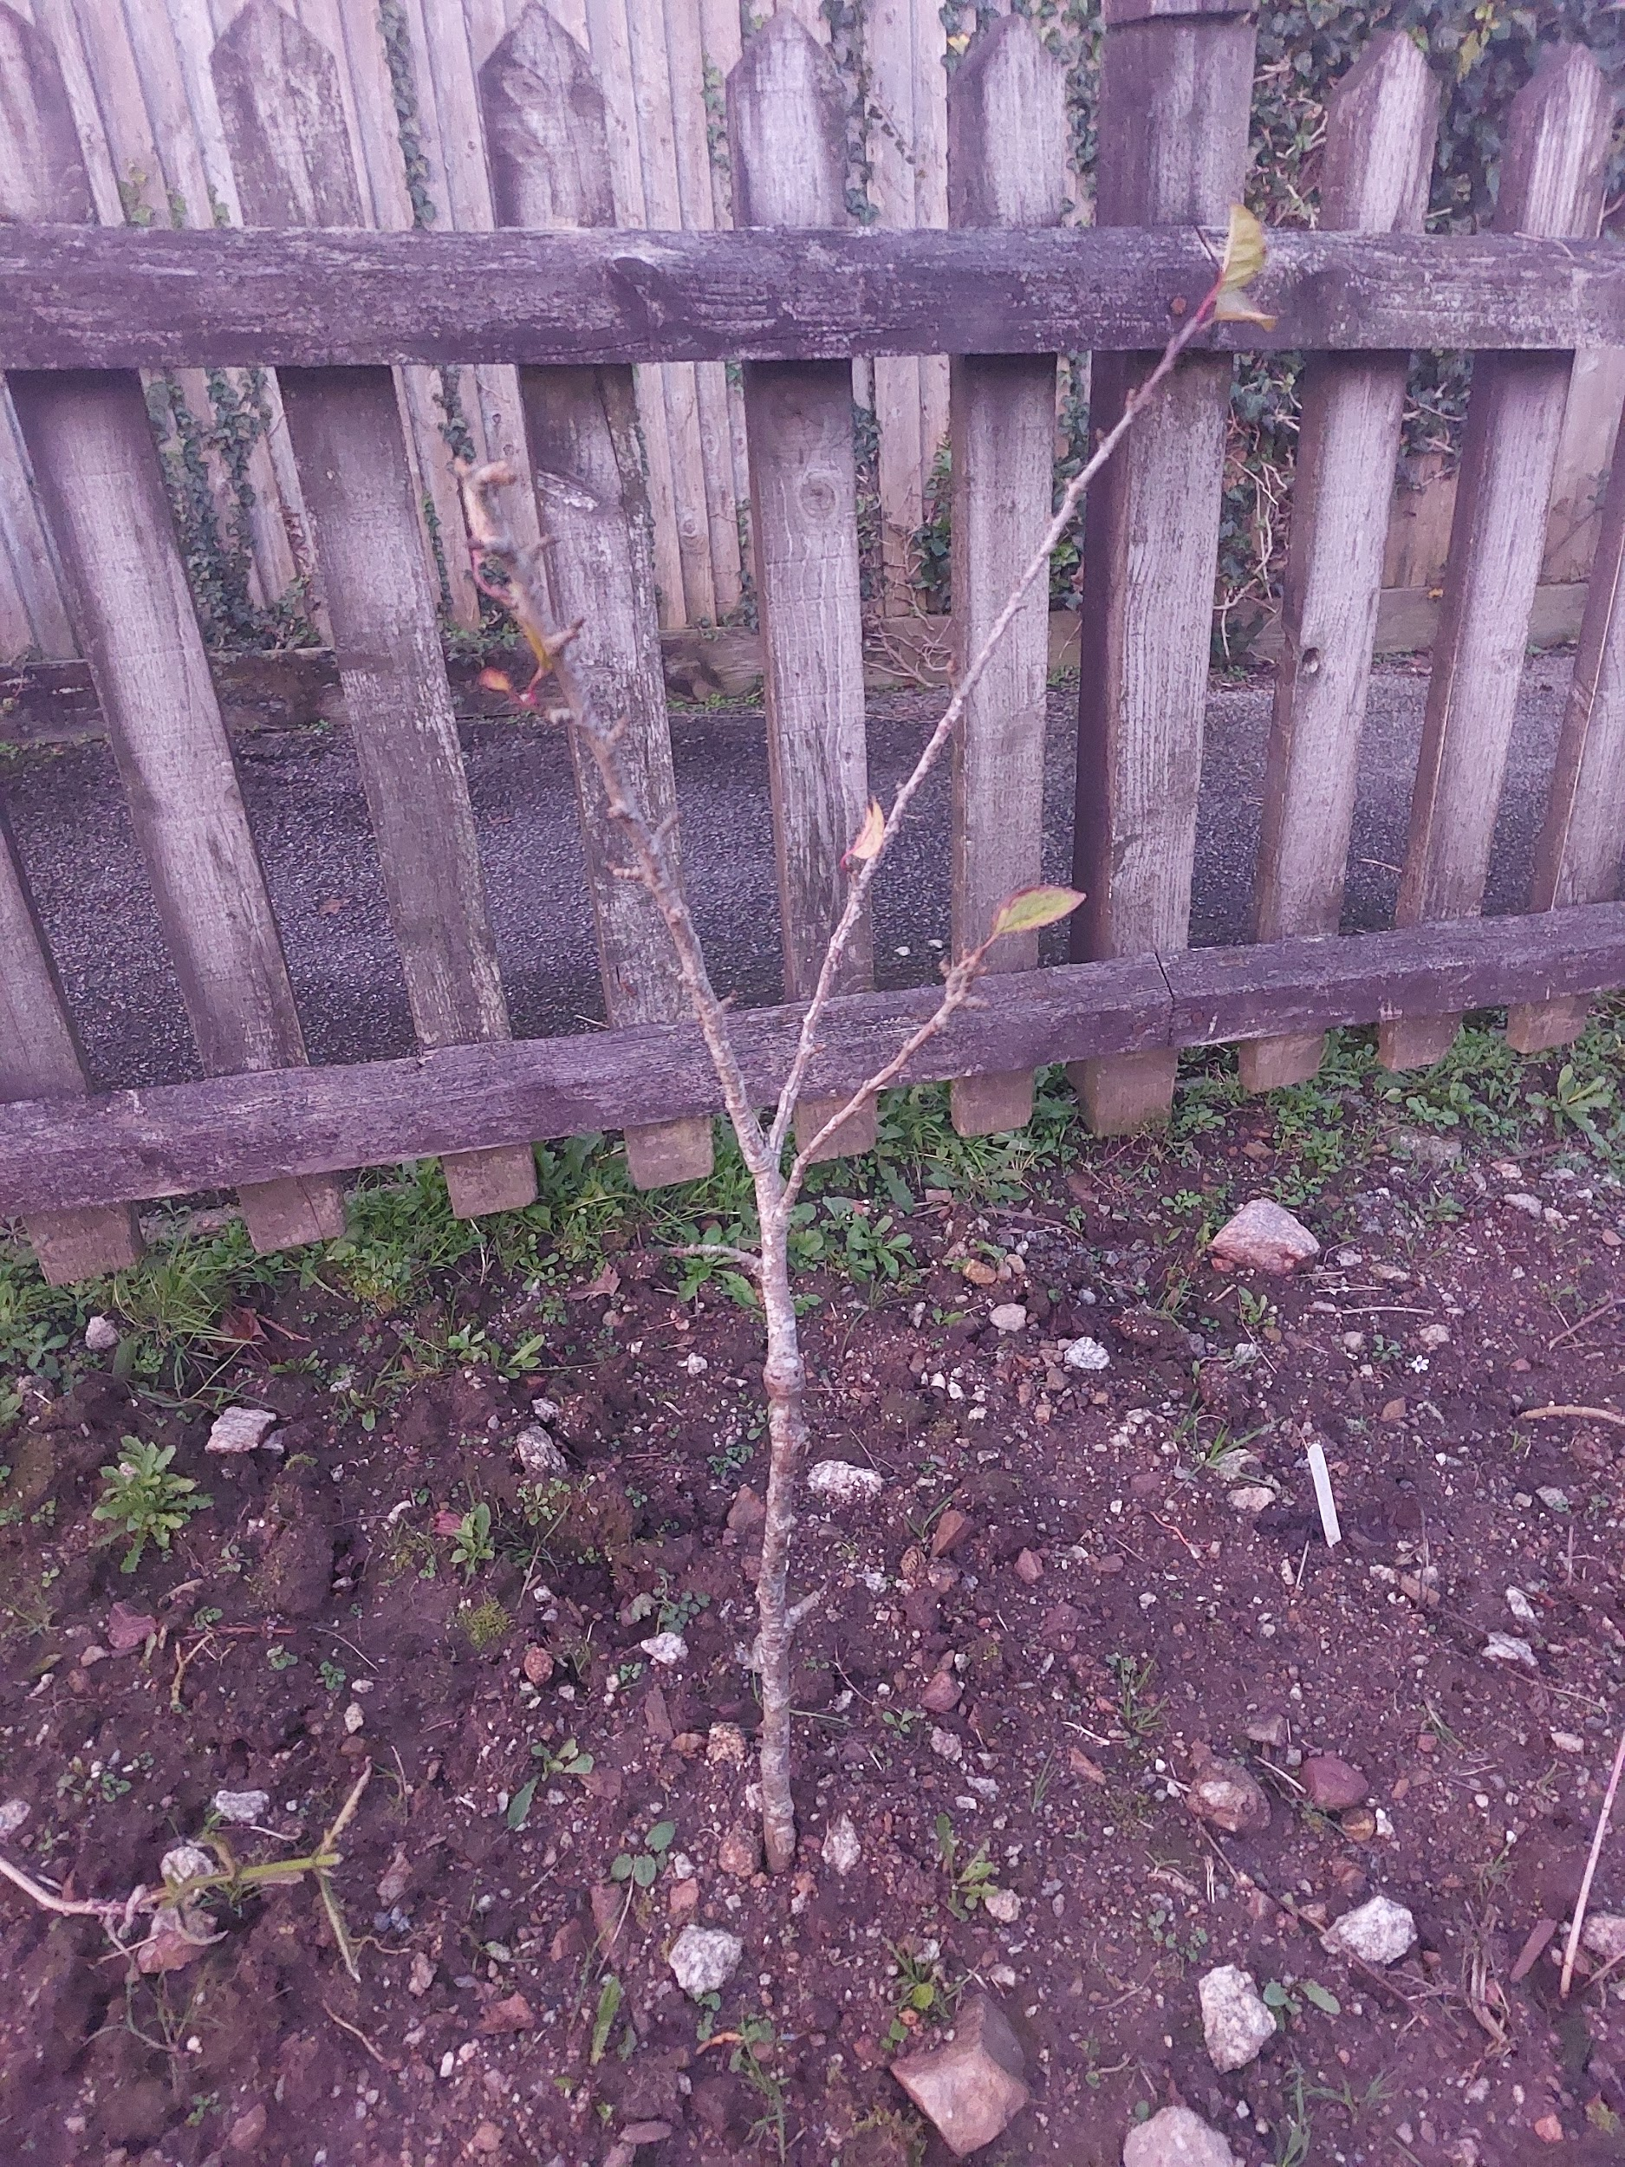

Pineapple sage, can be used to make tea One of our first 5 fruit trees in so far
Lots more will be happening in the coming weeks and months so if you would like to get involved please contact us and we can update you on volunteering sessions.
Next one Saturday 30th November meeting at 9.30am.

