

Your Parish Newsletter

Summer 2019

This is your parish newsletter for Summer 2019. Read on for all the updates on the work of Council. Find out more about the Parish Plan, trails and prevention of litter and fly tipping. Find out more about work taking place to reduce speeding through the village and how you can volunteer and make a difference in your community.

Climate Change

You’ll probably have noticed that Cornwall Council and many parish councils have declared a Climate Emergency. You may also have noticed that Lanner Parish Council hasn’t. Why not?
Climate change is happening. Whether or not one believes a changing climate is caused by human activity or by natural phenomena is not really the issue.
Declaring a “Climate Emergency” is to merely state the obvious. The concern is that declaring “an emergency” may lead to complacency (so, we’ve ticked the political box) or (more likely) policies will be developed which have little or no impact on the problem and may have negative consequences.

Climate change is a global issue and unless it is tackled globally there is little or no action that Cornwall can take unilaterally to have any significance on the future. The best that can be achieved is that, as a community, we build up resilience and resources to tackle the effects of what is to come. That is what the parish council seeks to assist. Climate change, sustainability and biodiversity are at the core of all decisions the Council makes: that is evident already in our Development Plan, Emergency Plan and will be in our revised Parish Plan.

To address climate change at macro-level, the number one issue is to curb and reduce the level of population worldwide, now standing at the highest level in history. If we don’t look to that, climate change or its socio-economic consequences will reduce it anyway through war or famine. So, perhaps we should start by discussing and lobbying for birth control policy and education; discussing limiting state support for larger families; and considering such matters in our international relations.
We also need to address society’s inherent desire for “growth”. The combination of expanding populations and expanding economic activity complete the equation for increasing levels of pollution in air, water and land.

Cornwall Council can help determine the quantities in that equation locally through strategic planning: particularly through review and revision of the Cornwall Local Plan. In fact, mitigation of the effects of climate change should be at the heart of all their decisions. That is not an easy task, given the targets and policies set by national government: but this is an emergency and so where national dictates work against local efforts to combat climate change then they must be challenged.
If Cornwall Council is to play an effective part in leadership then it must show consistency. Pressing for growth, increasing road capacity, building more and more houses, facilitating more air travel: all these things reduce the perception within the community of sincerity or urgency of purpose.
The consumption of fossil fuels is a major concern not only because of their effect on climate but also because of the need to free ourselves politically and economically from reliance on imported energy. In addition, despite the temporary relief to “Peak Oil” provided by shale gas, fossil fuels are of finite supply. So, moves away from fossil fuels are inherently a good thing.
The likelihood of effective international action taking place is remote: the USA, China, Russia, Brazil, OPEC (The Organisation of the Petroleum Exporting Countries) countries will all place self-interest first. In addition, people have aspirations, and these tend to be to emulate standards of living in the west. Is it possible to change those aspirations in a world which is propelled by economic growth and private wealth?

So, there seems very little we can do at the micro-level to avert some radical changes to our future environment. The value in micro-level planning is in promoting acceptance of a new culture of awareness towards pollution and the environment and to take steps towards mitigating what may become unalterable impacts on our lives.

For Cornwall to take unilateral action to become Carbon Neutral by 2030 seems not only unachievable but possibly also undesirable. Given the low level of average income in the county relative to the rest of the UK, such a policy would make most people relatively even more adrift of the national average. Unless there was a positive national wealth redistribution policy into Cornwall (and other low-income areas) poverty levels are likely to rise and the ability to take physical steps to mitigate climate change effects will be impaired. Carbon Neutral is not Cost Neutral. Given that the effect of Cornwall becoming carbon neutral will have no real impact on climate change, it seems unwise and even masochistic to be out of step with national targets on this issue.
How will we know when Cornwall becomes carbon neutral? The methodology of gathering data needs to be transparent and capable of scrutiny by the public. Do we really know where we are now with any degree of accuracy? The methodology is very important. For example, if a tourist visits Cornwall from Germany, to what degree are his carbon emissions attributable to Cornwall versus a tourist coming from Winchester? Similarly, if a Cornishman flies to a destination from Newquay airport are his carbon emissions different if he travels to the same destination from Exeter airport?
First and foremost, though, Cornwall Council must speak for itself. Can and will it become carbon neutral? How will Cormac and other assets be incorporated into calculations (or not)? Cornwall Council can actually control carbon emissions generated by its activities whereas for Cornwall as a whole, it can only have aspirations. Has the effect of carbon neutrality for Cornwall Council been monetarised and its impact on Council Tax increases been calculated? Will it precipitate rises in Council Tax so high as to require a referendum? How would you vote?
Specific Local Actions


Transport: Electric cars seem to be the way forward. Public transport is of limited use and efficiency in rural areas and more suited to urban or inter-city journeys. Perhaps the biggest deterrent to walking and cycling in rural areas is risk from traffic: partly because there are no pavements but most importantly because of speed. A reduction in speed limits to 40 mph where possible on rural roads would be an encouragement. There is also a need to encourage people to think about using the car only for purposeful journeys: the sheer volume of seemingly aimless cars in the countryside is a very real phenomenon.


Housing: Build fewer houses. That will have a big impact on reducing (or not increasing) carbon emissions. Take a more restrictive approach to green field development. The economics of making many existing homes more energy efficient is questionable, particularly listed buildings.


Energy: All commercial buildings should be encouraged to have solar panels on roofs, and this should be mandatory for new commercial buildings. At this point in time the provision of new large-scale energy farms is questionable on grounds of economics, connectability to the National Grid, and environmental impact. But the issue should be kept under review.


Environment: Planting more trees is very sensible. Wildlife and biodiversity seldom get sufficient weight in decision making. The biggest threat here is “urban growth”: the physical impact of ever more concrete and tarmac and vehicle movement.

Waste: Making recycling easier is very important. There should be more local recycling centres rather than fewer large ones. The current trend to centralisation may be more economically efficient from an operational point of view but for rural communities this means greater carbon emissions!


Other Concerns
Water: Ironically, although climate change may precipitate a rise in sea levels it may also add to water shortage. Given Cornwall’s extensive coastline, should Cornwall Council facilitate or invest in desalination plants? Alternatively, do we need another inland reservoir?

Emergency Capacity: Cornwall’s hospitals and emergency services are already stretched beyond capacity and a substantial investment is required to bring them up to a standard where they could reliably cope with health and safety issues flowing from severe climate change. This requires a commitment to both capital and running expenditure increases. It also requires great investment in community care. How will this affect Cornwall Council’s political and budgetary priorities?

Sea Defences: The effects of climate change on future coastal development are commendably embedded in decision making but are there plans for community funded coastal defence plans to protect existing property and where and when will these take place? Will they all take place by 2030? To what extent would the private sector be expected to either contribute to communal action or simply look after itself?

Quality Information: There is a lot of misleading information being put out under the “climate change” umbrella which is driven by other agendas and is not based in fact or sound science. This could have a damaging effect on core industries such as agriculture, fishing and tourism as well as the environment and biodiversity which they support. There is a role for Cornwall Council to play as a provider of sound data and tested opinion from which sensible decisions can be made. For example: emissions calculators can show a 100% difference in their results (see https://www.finavia.fi/en/newsroom/2018/what-are-climate-emissions-my-flight-try-out-most-popular-emissions-calculators)

Get Engaged

Let us know what you are doing and thinking on this looming crisis. Can others be inspired by things that you are already doing? Are there ways in which the parish council can act as a coordinator for community action? Visit the parish council website and pick up on our current thinking in the NDP and the Emergency Plan. And engage with our review of the Parish Plan.
Lanner Neighbourhood Plan
The Lanner Neighbourhood Plan was “made” on 11 March 2019 by Cornwall Council after it was given community approval by referendum. It now stands as part of the Cornwall Development Plan with full weight in consideration of all planning applications.
The Plan is based on the principles of sustainability which include an appreciation of the effects of climate change and the need to maintain and enhance the natural environment and biodiversity.
It identifies the built environment by a settlement boundary, outside of which development is unlikely to be permitted except in very special cases. The basic requirement for housing in Lanner as set out in the Cornwall Local Plan can be accommodated by infill or rounding off within that settlement boundary. At the time of writing we have virtually met this requirement with houses built, under construction or with planning given. There is still the possibility of some affordable housing for local needs being met on exception sites but allocations in neighbouring areas may well accommodate that.

You can read the full Plan at: www.lanner.org.uk

SOS in Lanner!
Working in partnership with the Cornwall Rural Community Charity and Cornwall Council’s ‘SOS project’ great improvements have been possible at the entrance splays to Lanmoor Estate.
The area had become overgrown making use of the seat less than comfortable and doing little to enhance the street scene. So, the parish council has taken a licence of the front part of the splays from Cornwall Highways and are acquiring the freehold of the back part, also from Cornwall Council, to manage the whole area to a good standard.
Volunteers from Cornwall Council’s staff teamed up with members of the parish council and its contractor, Tidy Grounds, to clear the jungle of vegetation. On a hot day the volunteers toiled hard but, in the end, produced great results and were very satisfied with their combined achievements.
Volunteer Emma said: ‘It’s been really great to be part of something to make things in a local community better. I have really enjoyed it and will certainly be signing up to volunteer again!”
All were well sustained by Portreath Bakery’s famous Cornish pasties!
A huge thank you and well done to all those involved. The SOS team also helped in repainting fencing around the Strawberry Fields recreation area during the previous week.
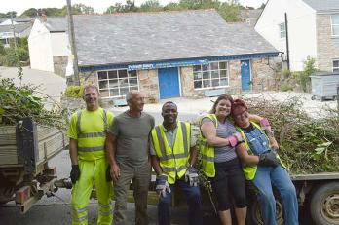
The parish council can now consider what else can be done to enhance this area and improve a pleasant amenity space in Lanner.
Financial Grants
Lanner Parish Council has a commitment to encourage, support and promote volunteer organisations and charities within Lanner for the benefit of the parish and the well-being of residents. Under s137 of the Local Government Act, Council makes an annual budget provision for Community Grants to help meet its aims.
Grants will be awarded based on the following principles:
- Assistance will be given based on need, merit and contribution to the community;
- Applicants must clearly show how the grant will benefit people living in the Lanner parish;
- Any grant awarded may be subject to ongoing monitoring and evaluation;
- Organisations should not make a presumption that funding will continue on a year to year basis.
The Process
- To apply for a grant, you must be a charity, community group or local voluntary organisation operating or providing a service to communities in the Lanner parish.

- All funding requests must be made using Lanner Parish Council’s grant application form;
- All application forms must be fully completed and signed: regrettably the Council will be unable to consider incomplete or unsigned applications.
- All applications must also include your last set of annual accounts. New/start-up organisations should submit a financial statement containing their proposed budget.

Eligibility
Lanner Parish Council uses the following criteria to decide on grant applications:
The scheme is only open to: Community Organisations, Local Charities and Community Interest Companies.
- Adherence to the grants policy process;
- Bodies must have a bank account in their own name.
- Projects must deliver a benefit to the residents of Lanner.
- The difference the project will make to the lives/activities of Lanner residents;
- Evidence of a well-managed group, including previous experience;
- Financial viability and sustainability of the project;
- Evidence that funding has been sought from other sources, including your own fund raising;
- Funds remaining in the budget for the current financial year for organisations/projects of your kind.
The Council reserves the right to award less than the amount requested or to reject an application.

Applications will be considered at the October Council meeting so please apply now! Forms can be downloaded from Council website, requested by email to: lannerparishcouncil@outlook.com or telephone 01209200551.

Slow Down!
Residents continue to express grave concern about the speed of traffic throughout Lanner and these concerns are shared by your Council.
A host of proposals are frequently put before Cornwall Council but are usually not possible due either to a lack of money or a wall of rules, regulations and policies.
To get any minor traffic control works completed a bid for funding must be submitted to the Community Network Highways Budget. This sees us competing with the major towns and other villages to get a small slice of what is a cupcake rather than a Victoria sponge! This is all to achieve small measures, for example relocation of zig zag lines and the introduction of yellow lines to improve traffic flow and pedestrian safety around Lanner School. Although, the Parish Council can submit schemes and requests it is most unlikely that anything will be approved unless it is fully supported by the local Ward Member. For Lanner that is Cllr John Thomas, so if you feel strongly in support of such measures be sure to petition him for action. The next round of funding allocations takes place in October: last year Lanner got nothing so the need for a local clamour is great.
Focus on what the parish council can do has been keen and several initiatives have been taken. Wheelie bin stickers have been purchased displaying a 30mph sign and are available from the Council office for anyone living on Lanner Hill. Results show a real reduction in speeds on rubbish collection days – not because traffic is stuck behind the refuse lorry but because the street is offering reminders on the bins! There don’t seem to be many wheelie bins out in Lanner but there maybe further opportunity when new contracts are introduced by Cornwall Council next year.
Many will have seen the new sign at the eastern approach to Lanner. The Parish Council has purchased this to try and reinforce the message to motorists that a 30mph speed limit is applicable right along the A393 through Lanner.
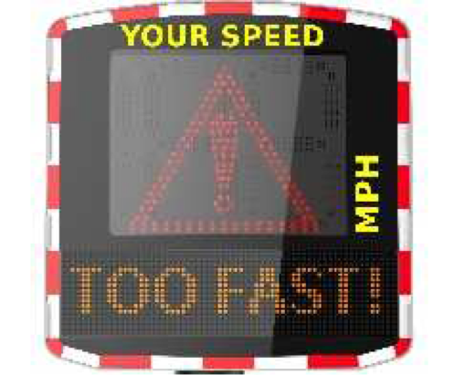

We have approval for several sites in Lanner so watch out for where the unit appears next!
The sign will also record data and offer statistics on the speed of motorists which help gain further support from Cornwall Council and enforcement action from the Police.
Please keep our sign smiling by staying within the limit!
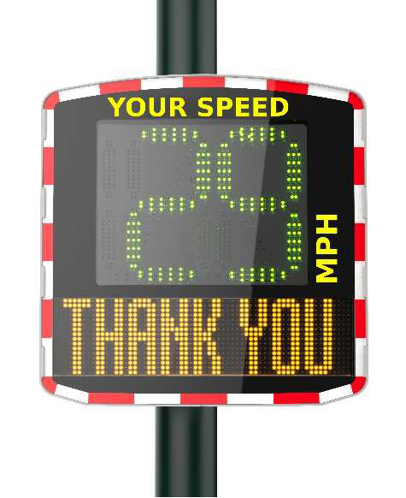

You can help too! Not just by driving within the speed limit but by getting involved in the Community Speed Watch team. More details about this are available from Cornwall Cllr John Thomas who leads the team of volunteers. (Mobile: 07503 547852 Email: john.thomas@cornwallcouncillors.org.uk)

A Note from Cllr John Thomas on Speed Watch
The above programme was initially set up by myself as a spinoff National incentive to educate irresponsible drivers of the need to comply with designated speed limits in our villages particularly in this case Lanner and Stithians which are in my Electoral Division.The scheme locally seemed to take for ever to gain real support from the Police until after several pressurised emails and meetings the tide was turned and our very successful LSW was born.Volunteer groups mainly consist of six per village and work a shift programme between them, this is independent of any Police presence at onsite speed checks once training has been completed.

Our present site is situated at Lanner moor opposite the petrol station, we hold regular twice monthly checks which involve recording speeds, logging numbers of any vehicles exceeding the 30mph limit, noting the make of vehicle and colour and any distinguishing details such individual stickers, it should be noted that the present law states that we must only record vehicles that are over a 10% variance plus 2 which makes no sense in our eyes,it means that motorists can exceed the limit up to 35mph, we are hoping to challenge this ruling so that 30mph does mean 30.All vehicles recorded are registered with date, times and in which direction they were travelling, the forms are all then sent off to Exeter for logging and getting letters sent out to motorists who have not complied with the limit.

Average times onsite vary but are no less than one hour per check, the results show that again on average 6 vehicles out of 140 are recorded as speeding but only above 35mph.
Other sites were suggested by the Police, the one suggested by them at the entrance to Henscol was scrapped as being too dangerous, another site is on the grass bank on the junction to Pennance Road, this too has had concerns raised by myself as being wholly unsuitable because we must be facing oncoming traffic with the gun not at 45 or 90%,this will inevitably invite challenges from motorists over any possible readings dispute,I have recently had a new email directive issued to myself offering our own sites through local knowledge of hotspots, we have come up with a few and they are sites at Lanner Hill above Lannarth Glas, the crest of Lanner Hill in both directions,South Downs, Trevarth now that my proposal to reduce the speed limit from 40 to 30 has been accepted in principle, Pennance Road and Sandy Lane, these are all in addition to our existing site at the filling station.

We will continue with this important scheme as long as it takes to realise some adhesion to Speed limits from motorists who generally give us a thumbs up whenever we are in operation although on a few occasions we have had rude signs and a small object thrown from a moving vehicle which fortunately missed us but dented the wing of a parked vehicle, such are the hazards of trying to promote something positive.

John Thomas can be contacted via: Mobile: 07503 547852 Email: john.thomas@cornwallcouncillors.org.uk

Tackling fly tipping, dog fouling and littering blight in our communities.

Communities have had enough of loutish, anti-social behaviour and those who insist on having no regard or respect for their environment or neighbourhoods are soon to come up against a new partnership which will see a much greater increase in Fixed Penalty Notices.

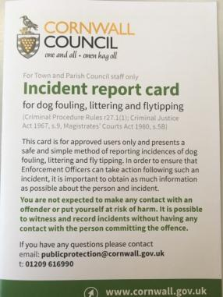
Recently, the Neighbourhoods and Public Protection directorate of Cornwall Council have been working in partnership with Town and Parish Councillors/ Staff across the Duchy to enable use of a new, non-contact enforcement tool for reporting incidences of fly tipping, dog fouling and littering.

The initiative forms part of a wider Community Enforcement Programme which aims to engage and empower Town and Parish’s across the duchy to report incidences of environmental crime in their communities. The programme is a response to the voice of the Cornish residents, where 58% felt that environmental nuisance was a very or fairly big problem in their local area (Cornwall Council Resident Survey 2017).
The new Incident Report Card gives approved Town and Parish Councillors and Staff the opportunity to record essential information SAFELY if they bear witness to incidences of fly tipping, dog fouling and littering in their communities. If the required information is provided to Neighbourhoods and Public Protection via the completed Incident Report Card, then a postal Fixed Penalty Notice can be served to the offender.
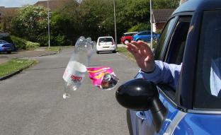
This project aims to change offender behaviour and reduce Environmental Crime levels in our communities

Lanner Neighbourhood Watch Group
You may have noticed the signs put up around the Parish by Lanner Neighbourhood Watch Group.
Our aim is to keep Lanner a great place to live by raising public awareness of how good citizenship can help to prevent crime. We would like to build on our existing scheme, but we need more members to join who share our interest in maintaining a strong, safe caring community.
From advice about keeping ourselves, our homes and possessions safe and secure to sharing information about avoiding fraud and cybercrime, membership is beneficial to everyone.
There is a lot of information about Neighbourhood Watch on the website www.ourwatch.org.uk or please contact Ann Shannon on 01209 821303 or why not use our membership form on the back of this newsletter.

As a footnote we would urge you to report incidents of a suspicious nature or anti-social behaviour direct to the police either by dialling 101 or by their easy to use website www.devon-cornwall.police.uk
This may help prevent further crime being committed and protect others from becoming victims.
If you would like to register to become a part of the Neighbourhood Watch in Lanner, please use the form at the end of this newsletter.
Thank you.
Lanner NHW.

Open Spaces
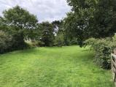
The Parish Council owns and manages a range of open spaces and facilities in Lanner for the enjoyment of residents.
Church Green:
This pleasant stretch of grassed area nestles between the churches on Rough Street. The area is leased from the Martyrs Memorial Trust and is maintained by Council as a peaceful oasis away from the noise and fumes of traffic.
Lanner Moor Playing Field:
The playing field is well served with an extensive range of play equipment and significant support from the community has allowed the installation of additional multi use facilities in recent times. The playing field is leased from the National Playing Fields Association.
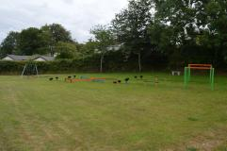
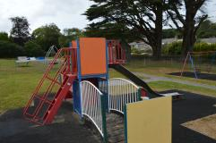
In order to protect the toilet facilities, which seem to be a particular target for unpleasant vandals, Council have found it necessary to install new doors complete with a charging facility. This means that access is only possible, between the hours of 9am and 7pm during the summertime and 9am to 4 pm in winter months, by payment of 20 pence. This gives the facilities some protection so that things like toilet paper can be provided! If vandalism does dissipate then further investment will be made with improved hand washing and baby changing facilities.

Strawberry Fields Recreation Field:

This area is owned by the parish council having been transferred from Cornwall Council. Under parish council management it has had play equipment and fitness equipment installed suitable for use by all ages.
Unfortunately, it is also an area frequently subjected to vandalism including the breaking of all trees and bushes planted to offer protective screening. This vandalism meant the picnic benches and BBQ grills had to be removed. The benches have been moved to Lanner Moor (sadly still subjected to graffiti!) but the frames for two communal BBQ units remain.
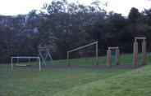
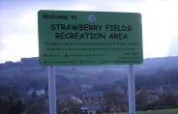
If you think you would like to use the grills, do contact the Council. The area could be used to stage community events (subject to permissions) and shared family fun!

Lanner Lawn Cemetery:

The cemetery lies just beyond the Churchyard, off Rough Street, and affords opportunity for burial and internment of ashes. It is owned and managed by the parish council.
Council is currently undertaking major groundworks to create a vehicular access for hearse and family cortege and some limited disabled parking. No less important, space will also be created for “natural” burials.
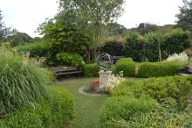
The project could not have been achieved without considerable support from Councillors and local contractors. Notably, ‘local lad’ Mike Caddy, Caddy Construction, has gone above and beyond the call of duty (or his contract terms) to move the project forward, not to mention many tons of earth too!

Council is currently commissioning some digital mapping which, once complete, will ensure accuracy in the plotting of burial sites. This will help facilitate the introduction of the Natural Burial site, a much sought after facility not previously available in Lanner. More information and updates on this project will feature on the website.
If you would like more details about this site or how to purchase Exclusive Rights of Burial please contact the Clerks.

Churchyard:

This area is owned by the Church of England who have recently been successful in an application to determine the area as legally ‘closed’. This is because there are no new burial sites available. Of course, being a closed churchyard doesn’t mean that it isn’t open to the public or that burials in family vaults or plots already purchased cannot take place.
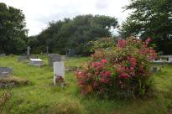
The burden of upkeep and maintenance of this area is heavy, and the formal transfer of this responsibility has now shifted to Cornwall Council. The parish council has, for a considerable time, cut the grass in this area and is now looking to work in partnership with Cornwall Council to continue to maintain a fitting resting place whilst protecting the biodiversity of the area. This will include the ground surrounding Christchurch itself which has been a closed churchyard for some time.

Other open spaces:
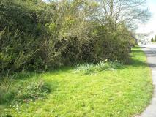
Lanmoor Entrance splays:

Council has maintained the cutting of grass at these splays for many years and was recently delighted to work with the Cornwall Council staff SOS project to carry out significant clearance works. Application has been made to Cornwall Council, who own the land, for the transfer of the area so that greater investment can be made in improving the area for all to enjoy.

Henscol:

Council is pleased that the open space at Henscol has now been transferred by licence to occupy, pending full devolution, from Cornwall Council. This means that the area is maintained and preserved as an open space by the parish council.

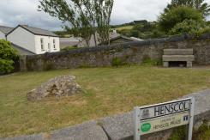
The small parcel of land at the entrance to Henscol remained within the ownership of the estate of the developer, K R Blewett. Council is delighted that Mrs Wendy Simpson and her daughter, Mrs Hayley Richards, have generously transferred this parcel of land to the Council. Again, this means that this area is protected as open space and preserved to enhance the street scene in Lanner.

Adjacent to this is a section of particularly wide pavement. Council has now secured management of the area and the installation of planters offers a colourful display for all to enjoy.

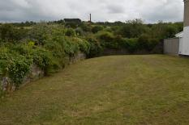
Consideration is being given to the transfer of other small sections of land/verges throughout the parish so that everyone can enjoy a well maintained and pleasant environment.

Tresavean Trail

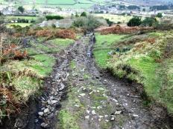
The parish council also owns virtually the full length of the Tresavean Trail. The council dedicated it as a bridleway which means that upkeep of the trail surface is the responsibility of Cornwall Council. The parish council’s ownership includes the Rough Street bridge but not the bridge (and steps) at Lanner Green which – strangely – remain in the ownership of Network Rail!

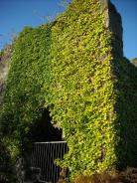
Tresavean Mine
The parish council has been seeking the devolution of the freehold in the old Tresavean Mine area from Cornwall Council. This area, which is held for public access, is on a minimal maintenance programme. The parish felt that it could be managed to a higher standard and its value to the community and to biodiversity increased. Sadly, Cornwall Council will not release the land. It has been suggested that council and local volunteers could invest time and money under Cornwall Council direction to improve the area. The parish council does not believe the level of investment required in a project which could take many years can be justified without community ownership.

Footpaths and Bridleways
A big thank you to all the volunteer footpath walkers that offer regular updates to Council on the condition of our footpaths and trails and to our Contractor, Anthony Strick, for cutting back all the vegetation in the past month to such a good standard. We are sure residents and visitors will continue to make good use of the full 12 miles of paths in Lanner!

Motor Vehicles
Council regularly receives complaints regarding the use of motor vehicles on footpaths and bridleways. Let’s be clear: it is illegal to drive either bikes, cars or other motorised vehicles on these public rights of way. The only exceptions are where landowners have express rights in their deeds for access purposes or for disabled users of mobility scooters.

Dog Foul
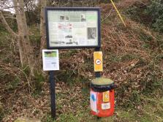
Council has put up reminder signs at the start of several trails regarding motor vehicles (and also dog fouling). Some signs have been knocked down or defaced. Technically, this is criminal damage and each incident is being reported to the police and Cornwall Council. Police patrols are being increased and there is the likelihood of covert CCTV being deployed, with Lanner now a “hotspot” for anti-social behaviour. Anyone found to be engaged in such vandalism will be prosecuted.

We are working closely with Cornwall Council and the Police to address these issues. Everything from the erection of signs to advise the unknowing or unconcerned, the erection of physical barriers (where possible), to passing intelligence about such activities to the police will continue in attempts to eradicate the problems. This activity puts other users at risk, erodes the surface of the paths and destroys natural habitat as well as being simply unlawful.
If you witness incidents of the use of motor vehicles on a footpath, bridleway please report these incidents to the police. This can be done by calling 101 or reporting via the Devon and Cornwall Police website, using the online reporting method: https://services.devon-cornwall.police.uk/crimereporting
Definitive Map
Some of the paths that have been used for many years by residents are not recorded on the Definitive Map. Cllr Liz Repper is leading a project to apply to add 10 of these routes to the Map. This will mean the paths are protected for the future and can be legally maintained by Cornwall Council. Government have set a deadline for registering “new” paths and so the aim is to have collated all the evidence by January 2020.
There has already been extensive consultation to get this far and we appreciate the signed witness statements already received. We will be at the Parish Office, Lanner Village Hall, ready to accept statements and answer queries on the following dates and times:
Monday 16 September 10am to 2pm and 6 to 9 pm
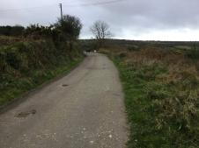
Thursday 19 September 10am to 2pm and 6 to 9pm

Perhaps you have old records, photographs of family days out when you used the paths or can simply confirm use of these routes. Please help us to protect these paths so that they can be enjoyed for generations to come.
Christmas Lights:
The Christmas Lights team have been facing some challenges over recent months as they set about their plans to light up Lanner for the winter festivities.
A serious matter for consideration each year is the safety of all the participants in the parade and subsequent gathering for the switch-on which has been traditionally staged at Lanner Square. The event has now become so popular that to hold this, in what is a public car park through which residents require access, presents a host of problems. Large numbers of people, particularly children, an adjacent highway, serving refreshments, affording space for both the Silver and Samba bands: these do not sit easily within all the health and safety requirements.
Council has consented to the event being staged in the safety of Lanner Moor Playing Field this year. The parade will still assemble at Lanner Primary School and then go in procession to the Playing Field where we hope to provide the usual festive cheer, with Father Christmas - along with a few additional features.
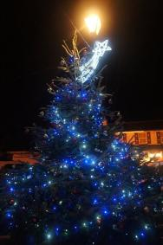
We hope you will join us on Friday 6 December with the lantern parade starting at 6.30 pm.

The additional difficulty the group face is the need for total replacement of the electrical infrastructure, that supports the lights, at Lanner Square. The wires, connectors and the high decorative lights around the poles have all been condemned by Cornwall Council, and in the interest of safety they have subsequently removed everything.
Quotations for the replacement of the wiring have been sought and understandably the cost is high. There are currently no funds available to support this work and applications have been submitted to various funding bodies. We have everything crossed! The provision of a Christmas tree in The Square lit through the help and generosity of local business and residents looks possible. It must be faced this may be all that can be achieved. Do look out for more updates on this project on the Council website.
The Christmas Lights Team are a small, dedicated and hard-working group who try to bring a little festive spirit at this significant time of the year. In order to hold the required Insurance cover, they act as a sub committee of the Parish Council and all financial transactions must be approved and overseen by Council. The group are grateful to residents for power supply and donations from businesses and locals alike.

If you feel able to join the team please email or telephone the Council office – it’s rewarding and fun and not all cold hands and feet we guarantee!
Communications
Sometimes residents seem unaware of what the Council is doing and miss opportunities to get involved in the life and work of the community.
All information relating to Council, both statutory information and latest news, appears on the website: www.lanner.org.uk. Please don’t forget to save us as a Favourite. The website is due for a makeover soon and we look forward to bringing you a brighter, easier to navigate site that will allow everyone to keep in touch.
We have been very grateful to post information on the Lanner Life Facebook page and commend the efforts of Rachel Glasier and the admin team, it’s a very difficult task to retain the value of such a group and ensure that the views aired are respectful and polite.
The production of a Newsletter is set to continue, with the aim being to achieve distribution by post to every household in the parish. Although it’s no mean feat to prepare for posting, Council considers this is a good opportunity to offer an update on its extensive and varied work both completed and what’s in progress.

Do let us know your thoughts and ideas about how you like to keep in touch with news and details of events.

This voucher entitles you to £1 off your purchase at Carharrack Animal Feeds.

Expires Monday 7th October 2019.

Please present this voucher at the till.

Single Use only.
Lanner Parish Council Newsletter Promotion 2019


Who are we?
A Parish Council is a corporate body - a legal entity separate from that of its individual members. Its decisions are the responsibility of the whole body. In 1894 an Act of Parliament created the civil parish, separating it from the church after its long history of delivering local services such as care for the poor, maintenance of roads and collecting taxes.
The Parish Council is an elected body in the first tier of local government. Parish councils are responsible for managing their own budgets. They are financed through the precept, an amount of money estimated for the coming financial year and collected as part of your Council Tax. Parish councils have a range of powers and duties in relation to the communities they serve.
The clerks are vital team members. The clerk is the proper officer of the council in law. The clerk provides advice and administrative support and takes action to implement council decisions. The clerk may have to act as a project manager, personnel director, public relations officer and finance manager. The clerk is not a secretary and is answerable only to the council as a whole.

Legally, councils can delegate decisions to clerks because they are trusted professional officers whose objectivity allows them to act for the council.

At Lanner, Councillors and Clerks work together as a team, combining knowledge and skills to deliver real benefits to the community they serve.

Who we are; how to contact and where to find us!

The Council Office is located upstairs at Lanner Village Hall. We not only carry out all the administration from here we also store the ever-growing archives and equipment needed for various projects and in case of emergency!
Our weekly Open Office hours are:
Tuesday 9.30am to 12.30pm
Thursday 2.30 to 4.30pm
We welcome visits from residents who would like information about services, have an issue to raise or just simply to find out more about community life.

It is with regret that we must inform residents of the loss of Cllr Mike Rabey.
Mike died on Monday August 12 after a courageous battle with illness. Council are grateful for his dedicated service and commitment to a range of issues addressed during his term of office.
Sincere condolences are offered to Lynn and his family.

Your Councillors are:
Chairman:
Cllr Ashley Wood: Penhalveor Farm, Penhalveor, Redruth, TR16 6NL
Tel: 01209 860239
Email: ashley@foodfromcornwall.co.uk

Vice Chairman & Chairman of Planning Committee
Cllr Tim Luscombe: The Count House, Wheal Buller, Redruth, TR16 6ST
Tel: 07968533504
Email: timluscombe7@gmail.com

Cllr Mary Anson: Lankevar House, Church Lane, Lanner, Redruth, TR16 6EU
Tel: 01209 211087
Email: maryanson@anson-care-services.co.uk

Cllr Chris Bosworth: West Trevarth Cottage, West Trevarth, Lanner Redruth TR16 5TJ
Telephone: 01209 821310
Email: chrisboz10@hotmail.com

Cllr Ross Marshall: 37 Lanner Hill, Lanner, TR16 6DW
Tel: 01209 215695
Email: rossandteresa@hotmail.co.uk

Councillor Liz Repper
Treviskey Cottage, Lanner Moor, Lanner, TR16 6JF
Telephone: 07597 314 186
Email: lilith69.lr@gmail.com

Councillor Tamsin Watson
Clinton Villa, Trevarth, Redruth, TR16 6AQ
Telephone:
Email: tamsin.watson1983@gmail.com

Councillor Trevor Wearne
12 Bell Lane, Lanner, TR16 6AP
Telephone: 01209 211029 mobile: 07831525905
Email: trevorwearne@icloud.com

Clerk, Elaine Youlton and Assistant Clerk, Teresa Marshall can be contacted as below:
Parish Office, Lanner Village Hall, 9 Lanner Hill, Lanner TR16 6DB
Tel: 01209200551
Email: lannerparishcouncil@outlook.com

Lanner Neighbourhood Watch
This Photo by Unknown Author is licensed under CC BY-NC
Our aims
- To create a safe, more caring community in Lanner
- To inform members of any crimes, potential dangers or scams which come to our notice.
- To look out for the needs of our neighbours, particularly the vulnerable and elderly.
If you would like to participate in this, please would you complete the form below, and sign it.
There is no membership fee at present, and we have no regular income, so our messages are sent by e-mail. Any information we hold about members is kept securely and is never shared with other agencies, apart from the police if this is legally required of us.
Our committee is in need on new blood if the scheme is to continue to be active. We meet for approximately one hour every 2 or 3 months. At present we meet on Monday mornings, but are happy to change this to an evening meeting if it is more convenient. If you think you could spare the time and are interested, please would you indicate this below.
Are you interested in a Neighbourhood watch scheme for your community? | YES | NO
Are you interested in becoming a committee member? It’s not an onerous task and helps keep the scheme alive. | YES | NO

Your Details:
Name
Address
Postcode
Tel No
E-mail

In line with GDPR regulations you give consent for Lanner Neighbourhood Watch to hold this information to keep you informed about the group. YES / NO
(If NO then you will not be able to receive communication from Lanner Neighbourhood Watch)
To view the Neighbourhood Watch Privacy Policy : https://www.ourwatch.org.uk/privacy-policy/
Signed _ _ _ _ _ _ _ _ _ _ _ _ _ _ _ _ _ _ _ _ _ _ _ _ _ _
Please return completed form as soon as possible to: Ann Shannon
Trevarth Corner, TR16 6AQ
Email : lannernhw@outlook.com
Telephone : 01209 821303

